Top of Form

EDU406 Q#2
1. The Reflective Practitioner must ______.
- Manage workloads as part of their role in planning and leading the profession
- Ensure a suitable work-life balance
- Both ‘a’ and ‘b’
- None of the above
2. Reflection is NOT _____.
- A simple ‘tick box’ activity
- A routine activity for a teacher
- Both ‘a’ and ‘b’
- None of the above
3. Deductive learning is _____.
- From general to specific
- Rule base
- From unknown to known
- All the above
5. The Reflective Practitioner has adapted _________.
- Ways of knowing
- Patterns of reasoning
- Both ‘a’ and ‘b’
- None of the above
6.Reflective writing focuses _______.
- On all aspects of an experience
- Critical incidences
- Specific details within an experience
- Ideas, concepts and opinions
7. The Reflective Practitioner is concerned with _____.
- Using a wider range of experiences and research to underpin the approach to teaching
- Using a wider range of pedagogies as a means to realize excellence in teaching
- Both ‘a’ and ‘b’
- None of the above
8: Working inductively means to _______ .
- Identify a goal and explore strategies to achieve it
- Plan a programme of discussion and observation to improve
- Reflect in an exploratory and trial-and-error fashion
- None of the above
9: By having an open-minded attitude, the Reflective Practitioner is _________.
- More reflective
- Adaptable to changing conditions
- Able to review experiences critically
- Is open to many new ideas

3: Reflection can be negatively influenced by _____.
- A lack of objectivity
- The Reflective Practitioner ignoring the truth
- None of the above
- Both ‘a’ and ‘b’
4: The Professional Development Journal is ______.
- A personal diary
- An on-going discourse
- A subjective dialogue
- A list of critical incidents
5: We understand frames through the use of ______.
- Metaphors providing explain them
- Metaphors to clarify them
- Metaphors to communicate logic
- None of the above
6 The Reflective Practitioner has adapted _________.
- Ways of knowing
- Patterns of reasoning
- Both ‘a’ and ‘b’
- None of the above
7: The study of parts of the community fall in ______.
- Evaluation
- Synthesis
- Analysis
- Knowledge
8: Concept-based learning means the Reflective Practitioner _________ .
- Transfers learning to new concepts easily
- Makes meaning and process information more deeply
- Has a more thorough working knowledge of theories-in-use
- Works with deeper levels of conceptual understanding
9: Being committed to the profession means _____.
- Being responsible for continuing professional development
- Being responsible for managing change
- Being responsible for changing policy and practice
- None of the above
10: Concepts determine _______.
- How a Reflective Practitioner’s perceptions are explained
- How a Reflective Practitioner’s beliefs are explained
- The frames for perception
- The ways a Reflective Practitioner explains experience
1: A Reflective Practitioner is able to _____.
- Question assumptions and values
- Think ‘outside the box’
- Question other people’s assumptions
- All of the above
2: We develop theories-in-use as Reflective Practitioners to ________.
- Understand theories as we apply them
- Predict what will happen when we apply theory to practice
- Explain situations
- Generate schemas for translating theory into practice
4: Effective writing in a Professional Development Journal _____.
- May include diagrams and drawings
- Is short and precise
- Both ‘a’ and ‘b’
- None of the above

5: Exploring practice using inductive action planning requires _____.
- Clearly defined and expressed success criteria
- Clearly identified evidence sources
- Both ‘a’ and ‘b’
- None of the above
6: An effective action plan is _________.
- Developmental
- Precise
- Shared
- All of the above
7: Professional knowledge relates to ______.
- Subject knowledge
- Communication skills
- Social interaction
- All of the above
8: A reflective action plan provides the Reflective Practitioner with _______.
- Targets, planning, evaluation
- Specific target-setting, identification of actions, evaluation of success
- Specific targets, activities, success criteria
- None of the above
9: Reflective writing ______.
- Is personal
- Links theory to practice
- Questions experience

Our assumption can be Perceptual.
A product for a teacher might include. All of above
A paradigm shift is. Brings a new set of concepts
Reframing for new learning is. Focused on inventing new strategies
Concept formation involves. Perception, abstraction, generalization
The highest level of Bloom taxonomy is. Evaluation
Using a reflective action plan is valuable. To set targeted action points
The Professional development Journal supports the RP to. Reflect on experiences
Inductive learning is. None of the above

Question 1:
Which of the following about teacher's professional knowledge and understanding is true?
- Once reflection becomes a habit you will not need to develop your reflective skills further
- Everyone always learns from experience
- Teachers need to develop reflection and evaluation of their practice
Question No.2:
According to Stephen Brook, reflective is?
- Locates teaching within the context of the school agenda
- Empowers the teacher to appreciate the bigger picture surrounding teaching
- a way for teaches to understand their problems
- None of the above
Question 3:
Which of the following is NOT a ‘best’ ? Pg.19
- Educates the whole child
- Follows the text closely to ensure coverage of the curriculum
- Students’ active participation in learning
Question No.4:
What does evidence suggest as being most important for a long-term commitment to Reflective Practice? Pg294
- Reflection is more effective when conducted collaboratively
- Collaborating with colleagues encourages the Reflective Practitioner to focus on what values inform his/her teaching
- Guidance and structure are key factors for Reflective Practitioners
- When the Reflective Practitioner knows what is best for children
Challenging environments
Question 5:
Which of the following is considered the least effective form of teacher development?
- Certificated Courses
- Workshops
- n-school mentoring
- Communities of Practice
Question 6:
Knowing-in-action is described by Schon as ___________.
- Our knowing is ordinarily implicit in our patterns of action
- When we cannot say what we know
- When we go about the spontaneous, intuitive performance of the actions of everyday life
- All of the above
Question 7:
What are the major mechanisms involved in critical thinking for the reflective practitioner?
- Self-regulation
- interpretation
- both ‘a’ and ‘b’
- None of the above
question 8:
Creative Thinking is not critical thinking because

- It is not logical
- It is not problem-centred
- It is emotive
- it is not based on ‘black-and-white’ thinking
Question 9:
‘Looking out’ is a combination of _____.
- A range of viewpoints about experiences
- Looking around’ and ‘looking back’
- Perspectives which direct the focus of attention
- None of the above
Question 10:
Which of the following assumptions does NOT underlie action research?
- Teachers and other education professionals have authority to make decisions
- Teacher and other education professionals want to improve their practice
- Teachers and other education professionals can and will engage in systematic research only if they are given adequate time and additional pay
- Teachers and other education professionals are committed to continued professional development

DATA refers to pg.40
- The analysis of an event
- The teacher describing, analysing, thinking and acting
- The four steps analytical process necessary for guiding reflection
3:
What is reflective practice?
- A process to evaluate teaching
- Process leading to activity in response to any aspects of the professional role
- Process of action to improve the professional role
- none of these
4:
What is the impact of reflective practices on the teacher
- It leads higher quality practice
- It changes teacher’s values and beliefs
- It leads to greater independence for the teacher
- It sustains inclusive environments
5:
Which of the following about teacher's teacher’s professional knowledge and understanding is true?
Once reflection becomes a habit you will not need to develop your reflective skills further
- Everyone always learns from experience
- Teachers need to develop reflection and evaluation of their practice
- teachers need to develop reflection and evaluation to support their own and others practice
6
What does ‘a lack of conceptual clarity’ mean?
- The educational community has different interpretations of reflection
- It confuses perceptions about what happens in the classroom
- It includes too many viewpoints and so becomes confusing for the individual
- does not account for students’ perspectives
7
According to Brookfield, which is the most powerful lens for teachers?
- The Self Lens
- The Student Lens
- the peers lens, the theory lens
8
Which of the following is an example of ‘warm’ feedback?
- Warm feedback extends thinking and raises concerns about teaching
- Warm feedback consists of supportive, appreciative statements
- Warm feedback raises questions
- none
9
Which of the following is not reflection in a professional setting?
- Deliberate
- Theory-focused
- Object-led
- Purposeful
10
The ‘critical lenses’ refer to
- The perspectives that a teacher uses to generate different viewpoints
- The focus given to the Reflective Practitioner by taking the different viewpoints necessary to reflect on practice
- A set of different viewpoints
- None

2:
Reflection-on-action can be described as ______________
- Thinking about what to do
- A reconstructive mental review
- Problem resolution
- Weighing the pros and cons of alternatives
3:
Which of the following is principle of Reflective Practice? Pg.8
Select correct option:
- It is problem-oriented
- It is based on action research
- It is data-driven
- It is research-led
4:
Which of the following is NOT one of the four steps in action research?
Select correct option:
- Identifying the research problem
- Developing a professional measurement instrument
- Obtaining the necessary information to answer the question
- Developing a plan of action
5:
Re-theorising is the means by which Reflective Practitioners _____.
Select correct option:
- Critically examine practice
- Critically examine theories
- Critically examine practice and theories in the light of theories
- Critically examine data and research in the light of theories
6:
Critical thinking is _______.
Select correct option:
- A biological process
- A psychologicaland cognitive process
- A communication process
- All of the above
7:
What are three levels of reflection?
Select correct option:
- Technical, empirical and practical
- Technical, practical and critical
- Rational, technical and critical
- Rational, practical and critical
8
What is question/ analysis in the reflective cycle?
Select correct option:
- Taking on the role of researcher
- Using quantitative data to make decisions
- Describing a situation
- Asking many questions

1:
Interpretation is the skills of ________.
Select correct option:
- Understanding and transmitting
- Cognition and communication
- Thinking and talking
- Receiving and sending information
2
Critical Reflection involves which of the following?
Select correct option:
- Analysing and c
- Analysing and evaluating
- Reasoning and evaluating
- Conceptualising and describing
2:
Which of the following is NOT one of the four steps in action research?
Select correct option:
Action Research is…Process, Collaboration, Improvement, Practice, Communication pg.250

3
What is part of the analytical process for the practitioner?
Select correct option:
- The identification of own assumptions
- The examination of the underlying values base
- Both ‘a’ and ‘b’
- None of the above
4
Why reflective practice is so important?
Select correct option:
- Research highlights the importance of reflective practice for changing personal values biases
- Research shows that reflective practice is essential for developing our understanding about teaching and learning
- Research shows that students grades increase when they are taught by a reflective practitioner
- Research shows that reflective practitioners are more profession
5
The most significant part of the model is _____.
Select correct option:
- Learning from experience
- Learning from reflecting
- Learning from information
- Learning from knowledge
6
What do systematic reflexivity and epistemic reflexivity focus on?
Select correct option:
- Beliefs, values and assumptions
- Methods and theories
- Suppositions, theories, beliefs and assumptions
- Praxis, values, theories and beliefs
7
When we think habitually, we _____.
Select correct option:
- Dismiss reasoning
- Have a fixed focus which distracts attention
- Ignore data
- None of the above
8
Double loop learning involves ______.
Select correct option:
- Changing personal assumptions (thinking deferentially
- Changing personal approaches changing rule pg.51
- Both ‘a’ and ‘b’
- None of the above
9
What factor makes reflection seem time-consuming?
Select correct option:
- Regular learning networks are very time-consuming
- Lack of leadership for Reflective Practice
- Regular learning networks are very time-consuming
- Staff is too busy

Quiz no 1
- Is not reflection in a professional setting? Object-led
- Best practice approach teachers must . Be committed to professional dialogue with other teachers
- Critical reflection facilitates_____ learning. Fosters transformational learning
- Why reflective practice is so important? Research shows that reflective practice is essential for developing our understanding about teaching and learning.
- True about teacher’s professional knowledge and understanding?
- What is reflection practice? Process of action to improve the professional role

describes a regular learning network. A learning “hub” which challenge practice and policy
- According to Moon. What are the key aspects of reflective practice? Aims to understand complexity
9.reflection is a form of ……Mental………..processing that we use to fulfill purpose or achieved anticipated outcome.

10.

1.What is the name of Competences that Characterize the Critical Thinker? Clarification
2. The reflective practitioner relies on___________.Synergistic thinking
3. Which of the following NOT involves internal commitment to discovery___________.Knowing what you have learned or what you want to learn from practice and experience needs some planning
4. What is the benefit of Benefits of concept-based teaching and learning_________
.A teacher who questions, investigates, explores and discovers
5. Epistemic stances_______.Traditional knowing
6. ___________ is a process by which the reflective practitioner learns how to organize information in logical mental structures. Conceptual learning
7. Absolute knowing’ is a process of ________.Learning from others
8.Identifying opportunities for you to discuss, reinforce and develop your practice is about inductive action planning___________ _.Inductive action plan
9. How many types of frames are_________.2
10. Reflecting on interpreting of both the learner’s experience and the phenomena being experienced so as to move beyond the partiality of previous understanding is__________.Hermeneutic Phenomenological analysis

Within a critical thinking framework, reasoning is conducted from…… a logicalframe work.
One part of learning from reflection relies teachers being open minded.These characteristics includer all but…………….

‘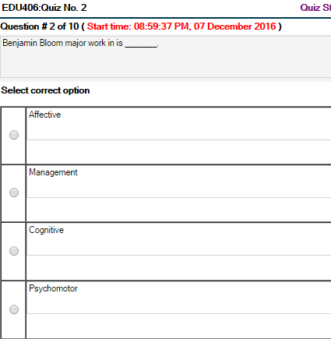

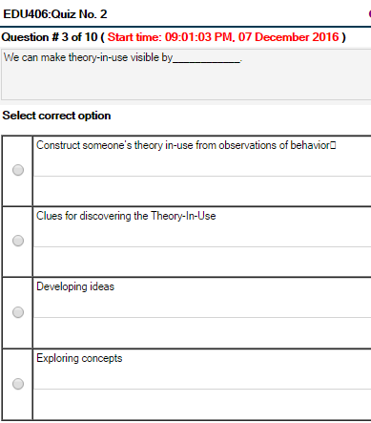

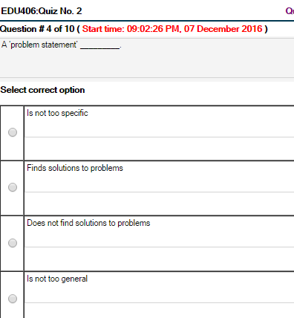

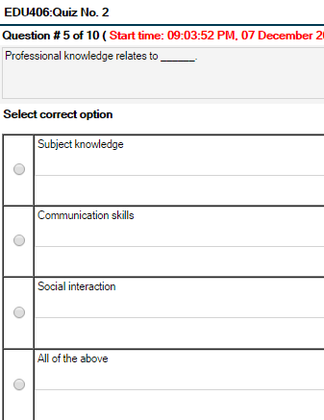

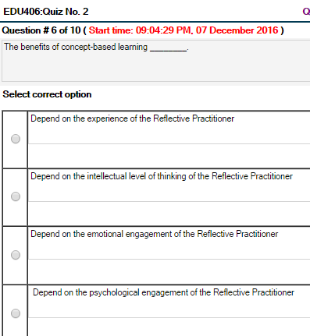

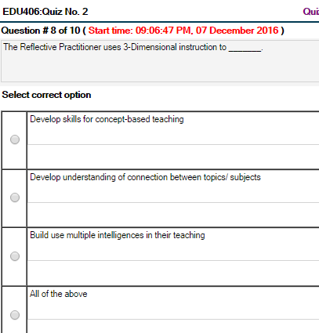

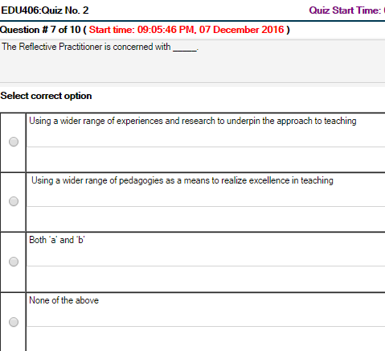

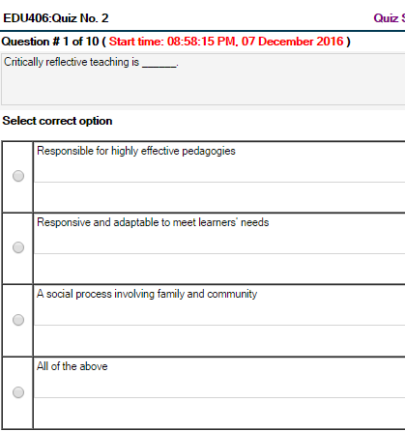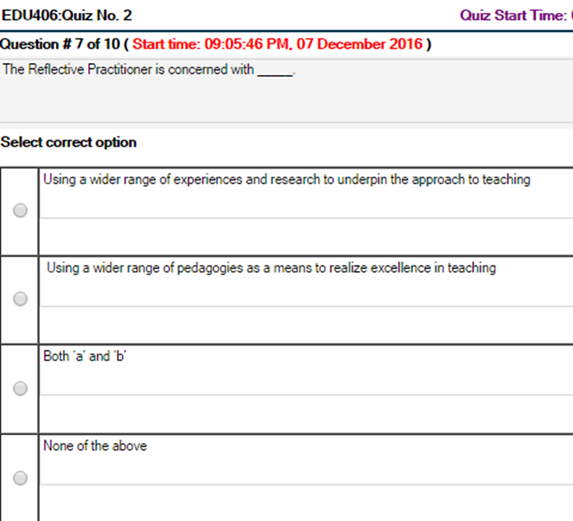Bottom of Form

